You are given a stream of points on the X-Y plane. Design an algorithm that:

* **Adds** new points from the stream into a data structure. **Duplicate** points are allowed and should be treated as different points.
* Given a query point, **counts** the number of ways to choose three points from the data structure such that the three points and the query point form an **axis-aligned square** with **positive area**.

An **axis-aligned square** is a square whose edges are all the same length and are either parallel or perpendicular to the x-axis and y-axis.

Implement the DetectSquares class:

* DetectSquares() Initializes the object with an empty data structure.
* void add(int[] point) Adds a new point point = [x, y] to the data structure.
* int count(int[] point) Counts the number of ways to form **axis-aligned squares** with point point = [x, y] as described above.

**Example 1:**

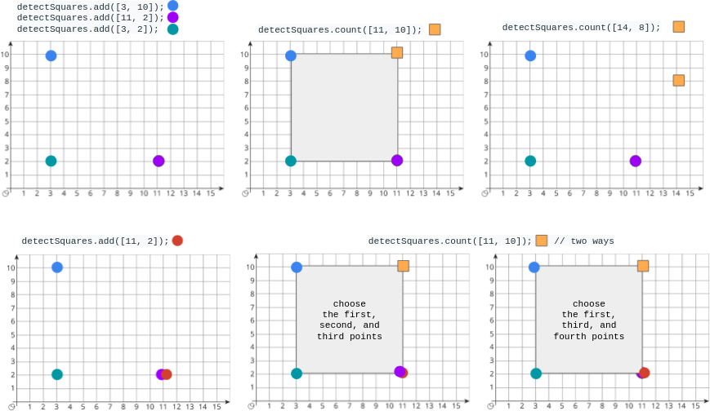

**Input**

["DetectSquares", "add", "add", "add", "count", "count", "add", "count"]

[[], [[3, 10]], [[11, 2]], [[3, 2]], [[11, 10]], [[14, 8]], [[11, 2]], [[11, 10]]]

**Output**

[null, null, null, null, 1, 0, null, 2]

**Explanation**

DetectSquares detectSquares = new DetectSquares();

detectSquares.add([3, 10]);

detectSquares.add([11, 2]);

detectSquares.add([3, 2]);

detectSquares.count([11, 10]); // return 1. You can choose:

// - The first, second, and third points

detectSquares.count([14, 8]); // return 0. The query point cannot form a square with any points in the data structure.

detectSquares.add([11, 2]); // Adding duplicate points is allowed.

detectSquares.count([11, 10]); // return 2. You can choose:

// - The first, second, and third points

// - The first, third, and fourth points

**Constraints:**

* point.length == 2
* 0 <= x, y <= 1000
* At most 5000 calls **in total** will be made to add and count.